**User Cohorts Creation**

**List of Cohorts Created**

1. Average Screen Time
2. Average Spent on App
3. Ratings
4. New Password Request
5. Last Visited Minutes
6. Status
7. User Cohorts

**Cohort Creation Rationale**

**Cohort 1 - Average Screen Time**

This metric provides insights into user engagement levels. Users with higher screen time are likely more engaged with the app, while those with lower screen time may need additional incentives or improvements to retain their interest.

**Criteria**: Users are grouped based on their average screen time in minutes.

**Screen Time Ranges**:

* 0-10 mins
* 10-20 mins
* 20-30 mins
* 30-40 mins
* 40-50 mins

**Size**: The number of users in each screen time range.

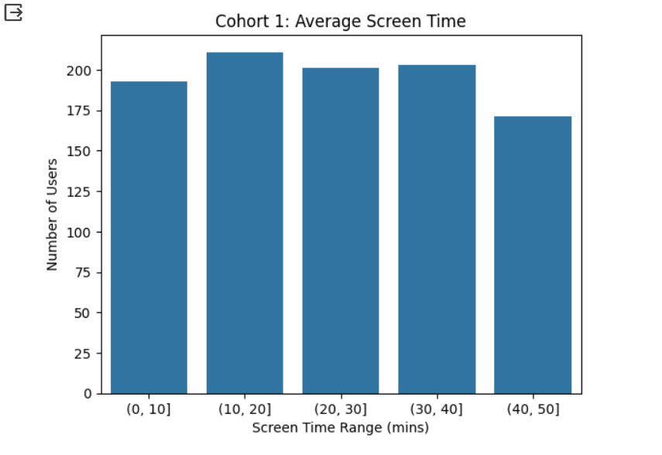

**Cohort 2 - Average Spent on App**

This metric directly impacts the revenue generated from the app. Understanding the spending patterns of users can help in targeting specific segments with tailored marketing campaigns or product offerings.

**Criteria**: Users are grouped based on their average spending on the app (in INR).

**Spend Ranges:**

* 0-200 INR
* 200-400 INR
* 400-600 INR
* 600-800 INR
* 800-1000 INR

**Size**: The number of users in each spends range.

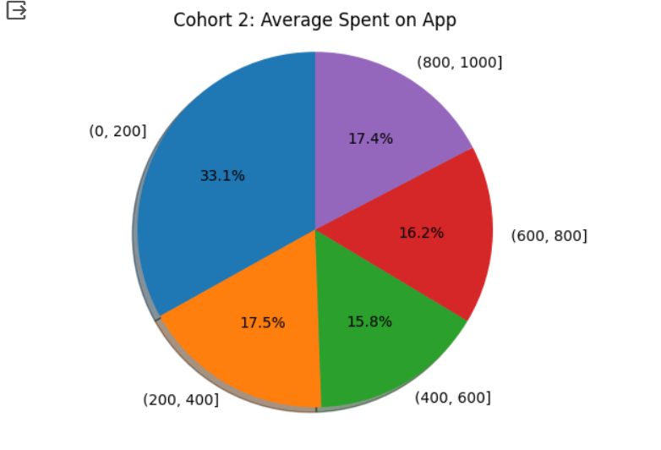

**Cohort 3 – Ratings**

User ratings are a direct reflection of their satisfaction with the app. Analysing the distribution of ratings can help identify areas for improvement and prioritize features or functionalities that users value the most.

**Criteria**: Users are grouped based on their ratings given to the app.

**Ratings**: Scores from 0 to 10.

**Size**: The number of users for each rating score.

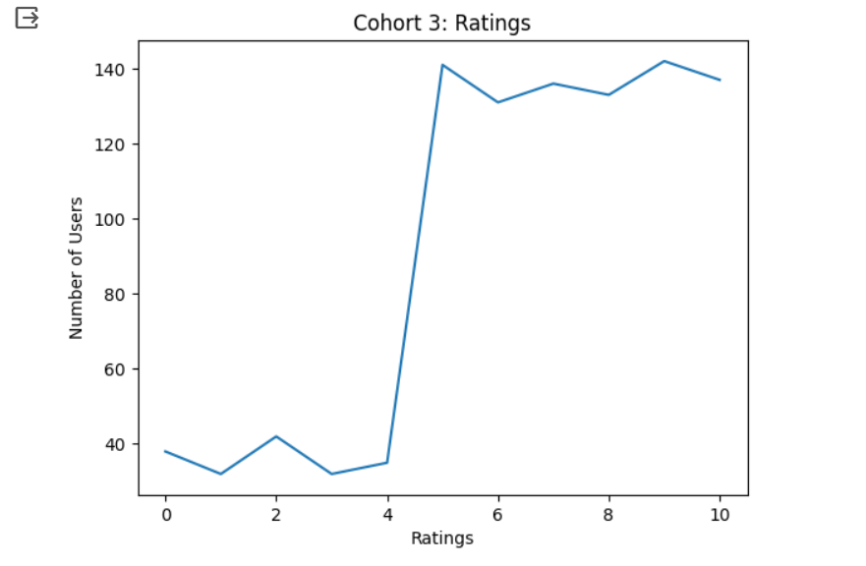

**Cohort 4 - New Password Request**

A high number of passwords reset requests may indicate usability issues or security concerns. Analysing this metric can help identify potential pain points in the user experience and address them accordingly.

**Criteria**: Users are grouped based on whether they requested a new password.

**New Password Request**:

* Yes
* No

**Size**: The number of users in each category.

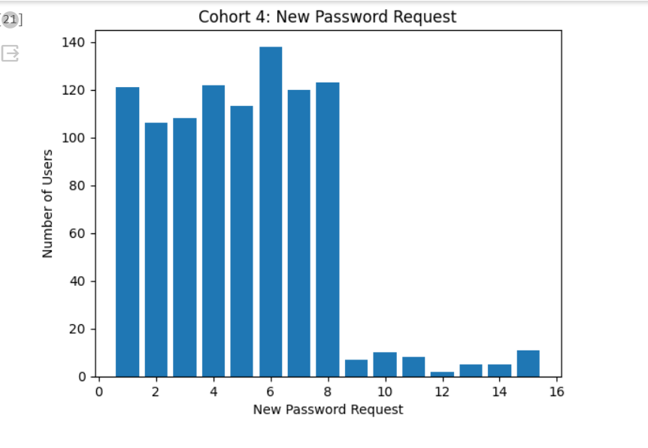

**Cohort 5 - Last Visited Minutes**

This metric provides insights into user retention and churn. Users who have not visited the app for an extended period may be at risk of churning, and targeted re-engagement strategies can be developed based on this analysis.

**Criteria**: Users are grouped based on the minutes since their last visit to the app.

**Last Visited Ranges:**

* 0-1000 mins
* 1000-2000 mins
* 2000-3000 mins
* 3000-4000 mins
* 4000-5000 mins
* 5000+ mins

**Size**: The number of users in each range.

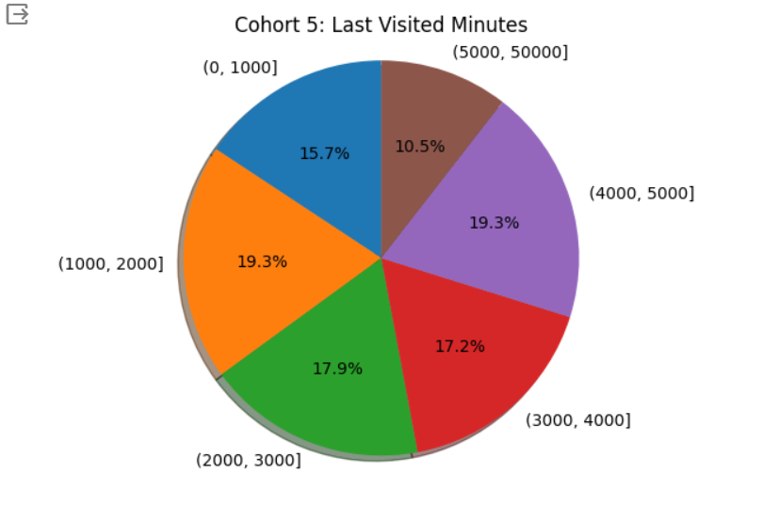

**Cohort 6 – Status**

Segmenting users based on their app installation status (installed or uninstalled) can help identify potential reasons for uninstallation and develop strategies to prevent or mitigate churn.

**Criteria**: Users are grouped based on their status (e.g., active, inactive).

**Status:**

* Active
* Inactive

**Size**: The number of active and inactive user

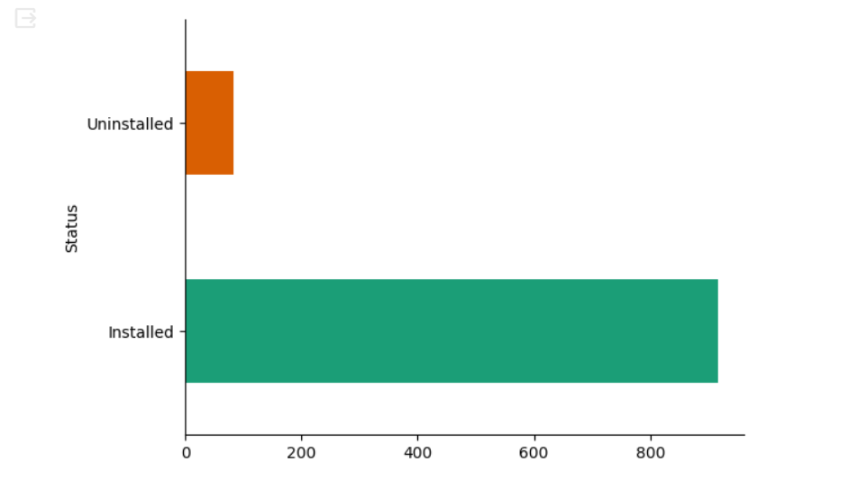

**Cohort 7 - Combined Users Cohort**

Combining these cohorts can provide valuable insights into user behaviour, engagement, monetization, and satisfaction levels, which can be useful for analysing business performance, targeting specific user segments, and identifying areas for improvement or growth opportunities.

